Threaded Binary Trees

------------------------------------------------------------------------------------------------------------------------

When we talked about preorder, inorder, and postorder traversal of binary trees in CS122, we saw that a stack(whose size is equal to the height of the tree) is always needed to accomplish the traversal - either explicitly or implicitly because of recursion.

Since these traversals are used often, we would like to avoid the space and time overhead of the stack if we can. A threaded Binary Tree is a way to do this.

What is Threaded Binary Tree?

In the Linked Representation of a Binary tree,
N = no. of nodes
2N = total no. of links
N -1= no. of non-null links
N +1= no. of null links.

A threaded binary tree is formed by replacing those null links with pointers as follows:

- If ptr->left_child is null, replace it with a pointer to the node that would be visited before ptr in an inorde rtraversal.
- If ptr->right_child is null, replace it with a pointer to the node that would be visited after ptr in an inorder traversal.

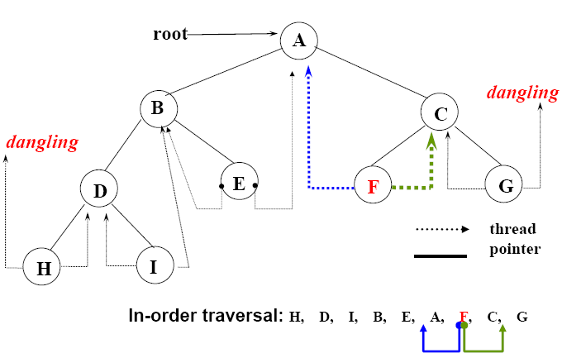

Representation of Threaded Binary Trees:

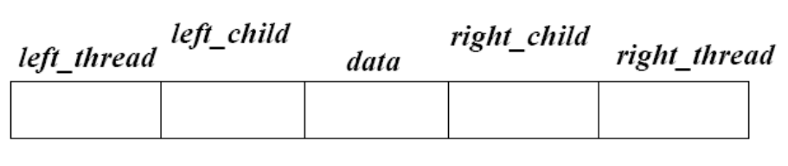

Struct node
{
Struct node *left_thread;
Struct node *left_child;
Int data;
Struct node *right_child;
Struct node *right_thread;
}

Threaded Trees

Example: Threaded Binary Tree for Inorder Traversal

+ A + + normal reference Start - threaded reference

+ B - + C + Finish

- D - - E + + F +

- G - - H - - J -

currentNode root;
WHILE (inorder traversal is not complete)
{ // traverse down left subtree until an empty subtree is found
WHILE (currentNode.lefttag( ) indicates a leftsubtree)
{ currentNode root of leftsubtree}
process currentNode; //reached a node with no left subtree

WHILE (currentNode.righttag( ) indicates an empty rightsubtree)
{ currentNode successor node for traversal;
process currentNode
}
// reached a node that has a right subtree
currentNode root of rightsubtree;
}
struct NODE
{
struct NODE *left;
int value;
struct NODE *right;
struct NODE *thread;
}
inorder(struct NODE *curr)
{
while(all the nodes are not over )
{
if(curr->left != NULL && ! visited(curr->left))
{
visit(curr->left);
curr = curr->left;
}
else
{
printf("%d", curr->value);
if(curr->right != NULL)
curr = curr->right;
else
if(curr->thread != NULL)
curr = curr->thread;
}
}
}

http://www.math-cs.gordon.edu/courses/cs321/lectures/threaded.html

